Shabbos Stories For
parshas terumah 5785
Volume 16, Issue 23 1 Adar 5785/March 1, 2025
Printed L’illuy nishmas Nechama bas R’ Noach, a”h
For a free subscription, please forward your request to keren18@juno.com
Past emails can be found on the website – ShabbosStories.com

The Bar Mitzvah Secret – A Story of True Self-Sacrifice
By Rabbi Zecharia Wallerstein, a”h


Rabbi Zecharia Wallerstein, a”h

There was a deeply religious man in Bnei Brak, a kind and pious soul. His grandson noticed something strange about him—unlike most men, his arms were completely hairless.
“Zaidy,” the boy would ask, “why don’t you have any hair on your arms?”
His grandfather always gave the same answer: “When you become Bar Mitzvah, I’ll tell you.”
The mystery stayed with the boy for years. Finally, the day of his Bar Mitzvah arrived. After the ceremony, at the celebration that night, he eagerly approached his grandfather.
“Zaidy, you promised—now you have to tell me.”
His grandfather smiled and said, “Wait just a little longer.”
The hall was filled with family and Torah scholars, a joyous gathering in Bnei Brak. Then, suddenly, a man entered the room. He was completely bald—no hair on his head, no eyebrows, no eyelashes. At first glance, the guests assumed he must be recovering from chemotherapy. People whispered “Hashem should grant him a refuah sheleimah.”
But the grandfather, the one with the hairless arms, saw him—and without hesitation, he ran to him. The two elderly men embraced, sobbing.
The room fell silent. No one knew who the man was, but the bond between them was undeniable. The grandfather led him to the front of the room, seating him among the rabbis. Then, he turned to the crowd and said, “My friend Chaim would like to say a few words to the Bar Mitzvah boy.”
Chaim stood up. His voice trembled with emotion.
“This is one of the greatest moments of my life,” he began.
He turned to the Bar Mitzvah boy. “Let me tell you our story.”

A Promise Made in the Darkest of Times
“We were both young boys when we were taken to Auschwitz. The Nazis killed our parents, our brothers, our sisters. I came with my entire family—my mother, my father, my little siblings. At the selection, they separated me from them. My mother, desperate to hold me one last time, ran to hug me. They shot her in front of me. Then they shot my father. Then my brothers and sisters. I was nine years old. In a matter of moments, I lost everything.
Then, they lined us up.
Your grandfather and I were among those selected to be ‘deloused’—because, as they claimed, Jews were filthy, full of lice. Their method? A pit filled with water and acid. They would push us in for a few seconds, let the chemicals burn, then pull us out.
One by one, the boys went in.
When my turn came, I was already broken. I had no reason to live. My family was gone. My home was gone. My town was gone. I had lost everything.
So, I made a decision: I wasn’t going to come out.
As I stood there, burning, I thought: The Nazis have taken everything from me—my family, my dignity, my very name. But then another thought struck me:
They haven’t taken Hashem [from me].
I still had Hashem.
I raised my arms, trying to pull myself out—but I was too weak. The acid was eating away at my flesh.
And then—your grandfather ran to me. He knew the risk. The Nazis would kill him for trying to save another Jew. But he didn’t hesitate.
He plunged his arms into the pit. Into the acid. He grabbed me under my armpits and pulled me out.

“…But He Didn’t Let Go”
His arms burned. But he didn’t let go.
The Nazis didn’t notice—perhaps they thought he was just doing his job, helping move the process along. But I knew the truth.
He saved my life.”

A Promise Fulfilled
Chaim looked around the room, his voice breaking.
“I was badly burned. If the Nazis had seen my wounds, they would have killed me on the spot. But your grandfather hid me, cared for me, kept me alive.
And I remember… we were lying in the barracks, two little boys, battered and broken. And he turned to me and said:
‘One day, you and I will be in Israel. We will have children. And one day, my grandchildren and your grandchildren will celebrate a Bar Mitzvah together.’
And today—today, that promise has come true.
That’s why your grandfather has no hair on his arms. Because those were the arms that stayed in the acid… so he could pull me out.”
Chaim turned to the Bar Mitzvah boy, his eyes filled with tears.
“What your grandfather did for me—that’s not human. That’s godliness.
And every single person in this room, every single Jew, every single human being—has that within them.
You just have to be willing to put out your arms.
You can’t just sit back. You have to do something.”

A Powerful Testament to
Self -Sacrifice and Faith
This story is a powerful testament to self-sacrifice, faith, and the unwavering bond between Jews. It reminds us that no matter how dark the world may seem, we must always reach out to help another—even if it comes at great cost. That is the essence of being human. That is the essence of being a Jew.

Reprinted from the Parshat Yitro 5785 email of Rabbi David Bibi’s Shabbat Shalom from Cyberspace.

The Man Who Was Pained
By His “Chilul” Shabbos
By Rabbi Yechiel Spero

Yankel Rosengarten from Yerushalayim, was apprehensive about his trip to America. He had never been there before but now he had no choice.
His school in Jerusalem, part of an orphanage for young girls, needed funds desperately and he had exhausted all other financial options. He had therefore resolved to make the long journey himself.
He would spend the first few days in New York and then move his way westward to the Midwestern cities of Cleveland, Detroit and Chicago. He would conclude his fundraising trip with a flight to Los Angeles, where he had a few wealthy supporters who had pledged generously to the orphanage.
As soon as he landed in Detroit he called a certain wealthy man named Reb Berel Gross. Before long, he reached Reb Berel's house. Yankel spoke with Berel for a while, discussing the school's dire financial situation and then sharing some thoughts of Torah learning. Yankel was pleasantly surprised that Berel was a scholarly individual who was well versed in every Torah topic they discussed.
Berel was sympathetic and understanding of the school's needs and wrote out a generous check. Yankel was pleased with the donation but even more satisfied that he would be able to stay with such a fine family for the next few days.
However, one comment caught Yankel off guard. Berel had mentioned something about the standard of kashrus in his home perhaps not being up to Yankel's standards. Yankel was confused. This was a man who was well versed in Torah learning and appeared to be a strictly observant Jew.
Yankel felt he could control himself no longer and asked Berel what the problem could possibly be. "I'm not sure if my Shabbos observance was always what it should have been," Berel answered, while averting Yankel's gaze, but he knew that an explanation was necessary.
Yankel sat back, quite puzzled, and listened closely to every word Berel said. "Many years ago, I lived in a small shtetl in Poland. The poverty was extreme and although my parents tried, supporting the family was very difficult. I tried to help out as much as I could but as a young boy of 12, I was limited. Finally, my father decided to send me to my uncle who lived in America. There, he figured, things would be better. America was the land where they had 'streets lined with gold.' My father felt that this would be my only chance to break free of my impoverished life.
"The trip by boat took several weeks and finally I arrived. My uncle came to greet me at the dock but his appearance startled me. Instead of the long beard that I had expected to see he sported a trimmed goatee. As a replacement for the long black coat my father wore he dressed in a stylish double-breasted herringbone gray sports jacket.
But perhaps what startled me most was the fact that he walked around with his head uncovered. I tried to hide my shock, though the contrast between what I was expecting to see and the reality was overwhelming. "He quickly used his connections to find me a job and I enjoyed being a carpenter's apprentice. However, when I did not show up for work on Shabbos morning I was immediately fired. This happened for three consecutive weeks.
Each time, my uncle would lecture me on responsibility and each time I would defiantly refuse to go to work. I couldn't believe that my uncle had forsaken his heritage. He entirely dismissed the notion that Shabbos was non-negotiable, rationalizing that during the era of the depression 'making a living' was not something that could be taken for granted. "On my fourth Sunday morning I was warned by my uncle to guarantee my boss that I would show up for work on the following Saturday.
The pressure was so great and I was a lonely 12-year-old with no family other than an uncle who was urging me to give up the most sacred tradition I had known, and so I gave in. When I showed up for work, I told the boss that I would work on Shabbos. "He kept on asking me throughout the week if I would come to work on Saturday and I answered him that I would, sincerely believing that I was in fact prepared to sacrifice the holy Shabbos for the security of my job.
Finally, on Shabbos morning I tearfully left the house with every intention of going to work. Instead of taking the train as I normally had, I walked toward my place of employment, crying the entire time. But as I walked up the steps and stood on the threshold of the shirt factory where I worked, the image of my father flashed before my eyes and I heard him warning me in his soft, loving tone, 'Guard the Shabbos, Berel. Guard the Shabbos.
“Suddenly I stopped. What was I thinking? How could I have even thought of desecrating the holy Shabbos? I turned around and ran as fast as I could, though I had no idea where I was going. I finally reached a park bench and begged Hashem for forgiveness. I knew I could never return to my uncle's house â€” but I had made a choice about what was dearest to me."
Berel looked up with red eyes at his guest and painfully recalled the event of which he was so ashamed. "I did not work that Shabbos. But every day of the preceding week I had planned to work on Shabbos, to desecrate its holiness. Shabbos isn't one day a week. You have to prepare a whole week for Shabbos and in that respect â€” I had failed. So, if you want to eat in my house, that is your choice."
Yankel stared at his host for a long while, overcome by the holiness of this man who had suffered for so many years not because he actually desecrated the Shabbos, but because he had planned to. He gently embraced his new friend and realized that, aside from the financial benefit of meeting him, he had gained in many more important ways from being in the home of Reb Berel Gross. (Touched by a Story, p. 98 R. Yechiel Spiro)

Reprinted from the Parshas Yisro 5785 email of Good Shabbos Everyone.

You Are Never Too Old!
By Rabbi David Ashear

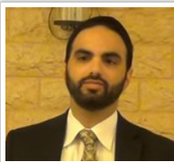
Rabbi David Ashear

Yoel* was on his way to a shidduch date when he saw an older man fall to the ground at a red light. He immediately pulled over to help. The man, Mr. Friedman*, brushed himself off and said, “I’m okay, I just lost my balance.”
Yoel offered to drive him home, but Mr. Friedman insisted he was fine. However, Yoel wouldn’t take no for an answer and helped him into the car. Even though Yoel was due to pick up his date in five minutes, he decided the chessed took precedence. He called to say he'd be late and drove Mr. Friedman home.
While driving, Yoel mentioned he was meeting a girl that night, and Mr. Friedman replied, “I never got married. I lived my whole life alone.”
Yoel was struck by the sadness of it and suggested, “Let’s daven for each other to get married.”
Mr. Friedman responded, “I’m 72. If I didn’t marry by now, I’m not getting married anytime soon.”
Yoel replied, “Never say never. Anything is possible. I’ll daven that you get married, and I hope you daven that I do, too.” They exchanged numbers and kept in touch over the years. Eventually, Yoel got engaged. During the vort, he received a text from Mr. Friedman:
“I get a mazel tov! I’m getting married next month! I want to invite you to my wedding.” Mr. Friedman, in his mid-seventies, was marrying for the first time! The hashgacha in this story is astounding—two men who had prayed for each other, one at 24 and the other at 74, got engaged at the same time! (Living Emunah on Shidduchim)

Reprinted from the Parshas Mishpatim 5785 email of The Weekly Vort. Excerpted from the ArtScroll book – “Living Emunah on Shidduchim.”

Time for a Photo
By Rabbi Reuven Semah

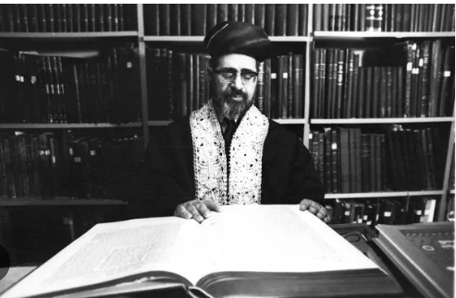
Rav Ovadiah Yosef, zt”l

Our perashah (Yitro) has in it the Ten Commandments. One of the laws is that it is forbidden to make a pesel, which is a graven image of idolatry, and also any “temunah,” which is a picture of that which is in the heavens above, etc. Let’s hear a great story about taking a picture.
When Rav Ovadiah Yosef zt”l was living in Cairo, Egypt, as the head of the Bet Din, one night the Rabbi and his Rebbetzin had to leave their home to take care of a certain situation. As they were walking in the streets of Cairo, some young bullies started following them. Soon they started cursing the Rabbi, “Here is the Jewish Zionist!” with looks of hate in their eyes. Slowly, the menacing crowd grew. Now the situation became very dangerous.
As they were walking, they passed a fancy photo shop. The Rabbi quickly told his Rebbetzin, “Let’s go into this shop.” It was a fancy boutique built in beautiful European style. The bullies wouldn’t come into this store, so they waited outside. The owner approached the Rabbi and his Rebbetzin and said, “May I help you?” The Rabbi answered, “Yes, we want to be photographed.”
“Ok, please stand here,” as he positioned them while adjusting his camera. The Rebbetzin said, “One minute,” while she adjusted her shoes, the whole time looking to see if the crowd disappeared. “Or maybe we should take the picture sitting down,” trying to stall for time.
Finally, the crowd got impatient and left. The photographer lost patience. “Are you ready now?”
“Yes,” responded the Rebbetzin, to the photographer who was unaware that he just saved their lives. The photographer took the shot and the Rav took out his wallet and paid. They hurried out of the shop and got home, the whole-time thanking Hashem for saving them. Shabbat Shalom.

Reprinted from the Parashat Yitro 5785 edition of the Jersey Shore Torah Bulletin.

Match Made in Heaven
By Rabbi Yechiel Spero

Shidduchim had not gone easy for Baila. She had been dating for several years and nothing seemed to work. Often, she would think that she was going to get married to a certain young man and then one of them would decide that it was not a match. But the years of frustration made it all the more satisfying when she finally became a kallah.

The Big Day Had Arrived
The approaching wedding brought with it many responsibilities and tasks to be accomplished, but finally the months of waiting came to an end. The big day had arrived. Baila arrived at the wedding hall very early and soon afterwards the hatan arrived. He appeared to be nervous, but he sat down and tried to calm himself. Many of the guests arrived and were enjoying the festivities. However, as the hupah was about to begin, it became apparent that the hatan was nowhere to be found.
His parents began to explain nervously that he had come to them terribly distraught, saying he did not want to go through with the wedding. They had tried to convince him not to leave but all their efforts were in vain, as were the efforts of his friends. Moshe’s mind was made up and he refused to reconsider. He just did not want to marry this girl. For the meantime, the impending disaster was kept quiet, but it would only be a matter of time before the kallah would hear the devastating news. Everyone there tried to think of a way to break the news to her but no one seemed to have a good idea of how to go about it.

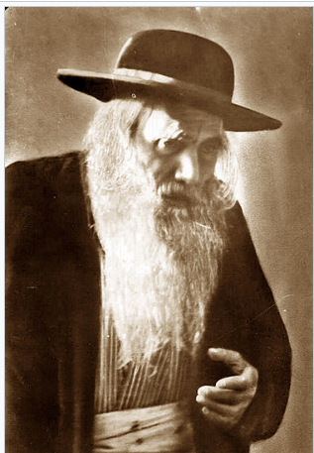
Rabbi Yosef Chaim Sonnenfeld

Rav Yosef Chaim Sonnenfeld, the Rav of Yerushalayim, was at the wedding and was immediately informed of the crisis. The Rav inconspicuously slipped out to where the hatan’s friends had gathered and were already discussing what had happened.
“Who wants a guarantee for a long life and nahat from all your children and grandchildren?” All the boys looked up and were surprised to see the venerated Rav standing next to them. “Anyone who is willing to marry this girl and prevent her from the shame she will incur from this embarrassing incident will be guaranteed a wonderful long life with endless amounts of nahat.”
One by one the young men, although impressed and tempted by the offer, declined. But one boy was willing. Quickly his parents were asked and with their consent he spent a few minutes with Baila. Her initial shock caused her to hesitate but she finally consented. And so they got married.
It is sixty years later and their children, grandchildren and great-grandchildren smile and are forever grateful that their grandfather’s unusual display of hesed allowed for their grandmother and grandfather to meet, get married and spend a long and happy life together. (Touched by a Story)

Reprinted from the Parashat 5785 email of Rabbi David Bibi’s Shabbat Shalom from Cyberspace. Excerpted from the ArtScroll book – “Touched by a Story.”

The Missing Wagons
By Asharon Baltazar



The eighteenth century was a difficult time to be a Jew in Eastern Europe. Once, in an attempt to avoid corrupt border officials, a Jewish man hired agents to smuggle nearly 200 wagonloads of wine across the Russian countryside. He had invested much money in this risky endeavor, and anticipated the day when he would hear of the wagons’ safe arrival.
One day, the man, who counted himself among the adherents of Rabbi Schneur Zalman of Liadi (the Alter Rebbe), was notified, like a bolt of lightning on a sunny day, that his 200 wagons had been caught and seized by the Russian authorities. Overcome by grief, the poor man barely managed to process the news before he passed out. Even worse, he could not be shaken awake. Whenever one of the people with him succeeded in reviving him, the man simply slumped back into a faint. This scenario repeated itself numerous times.
His plight was eventually brought before the Alter Rebbe, whose answer was puzzling but final: the wagons had not been seized.
The remark spurred a hunt for the missing wagons, and they were discovered, safe and sound. According to the drivers, during their flight across the Russian countryside, the sound of a carriage fitted with a bell led them to believe that they were being chased by the authorities. Concerned for their lives, the wagon drivers abandoned the caravan and fled on foot. As a result, the long entourage of horses tied to wagons clogged the road. Various passersby could not help but notice this and guided the horses to the side of the road, where they were tied up. The horses and their precious merchandise stood by the side of the road until, eventually, the drivers returned and brought the merchandise to the relieved owner.

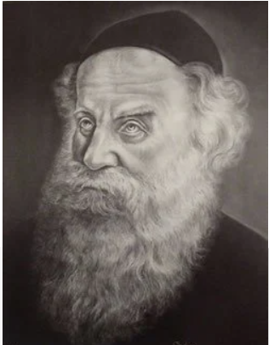
The Alter Rebbe

After this was all cleared up, the chassidim approached the Alter Rebbe again with a different question: How is it possible that someone who claims not to perform miracles is caught blatantly doing just that? How did the Rebbe know that the goods had not been requisitioned?
The Alter Rebbe waved the question off, explaining, “It was never a miracle. My answer was based on the teaching of our sages that G-d only sends a person suffering that he is capable of withstanding. When I heard that the man was unable to rouse due to constant fainting, it was obvious to me that 200 seized wagonloads of wine is not a challenge that G-d would send him. Such hardship was too much for him to confront.”
Note: This story (adapted from Shemuot Vesippurim, vol. I, page 32-a) is not meant to justify another's suffering, just to provide us with perspective as we go through our own challenges.

Reprinted from the Chabad/Org website

The Chofetz Chaim Vision

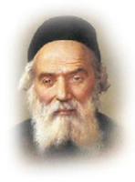

The Chofetz Chaim would travel from city to city to sell his sefarim and influence the various communities he visited with his unwavering impact. One time, he happened to be staying at a Jewish-run inn and was having a meal when a big broad-shouldered man in peasant’s clothing stormed in.
The man was apparently Jewish, though he didn’t show any signs of it. He demanded service and ordered a loaf of bread and an abundance of liquor. When they arrived, he downed the liquor quickly and ripped into the bread without washing his hands or making any bracha first.

Spoke to the Owner of the Inn
The Chofetz Chaim went to the owner of the inn and said, “Perhaps I should go over to that man and explain to him the proper way of eating a meal.”
The owner shook his head. “That man is Jewish, but he certainly doesn’t act it. He was snatched from his home when he was young to serve in the Czar’s army, and he’s lived with non-Jews ever since. He’s forgotten everything about Judaism, and he doesn’t want to know about it. He’s a lost case. Don’t waste your time on him.”
But the Chofetz Chaim thought otherwise. He went over to the man and sat down beside him. “Excuse me for bothering you,” he said. “My name is Yisroel Meir Kagan. I hope you don’t mind if I join you for a few minutes.”
The man looked at him with great surprise.

Aren’t You the Famous Rabbi?
“Aren’t you the one they call the Chofetz Chaim? The famous rabbi whom everyone has such respect for?”
“Well, everybody is wrong. The one that they should respect for is you!” answered the Chofetz Chaim.
The man was totally confused “What do you mean?”
“I’ve heard that you were one of the Cantonists taken to the Czar’s army when you were young. Is that true?”
The man nodded sadly. “It’s been so long since I was taken that I can’t remember my parents anymore.”
“And yet you survived and you returned to live again among your fellow Jews. That took a lot of courage, and I admire you for it!” “
You admire me? But I don’t keep any of the Jewish laws, I don’t go to the synagogue, I don’t say blessings…”

The Empathy of the Chofetz
Chaim for the “Lost” Jew
“Of course not!” said the Chofetz Chaim. “It’s been years since you’ve done these things. You’ve been in a non-Jewish environment all these years. How could you remember the Jewish ways? Would you allow me to help you learn them again?”
The man looked at the Chofetz Chaim for a long time, then he suddenly burst into tears. “Since I’ve been back, everyone has avoided me. You were the first to take any interest in me at all. If you are willing to teach the Jewish laws to an ignorant man like me, I’d be happy to learn them.”
The Chofetz Chaim sat down with the man and began learning until, eventually, the man once again became a Torah-observant Jew. By not looking down on the man, the Chofetz Chaim won him back to Yiddishkeit. With the proper vision a sleeping neshama was once again reignited.

Reprinted from the Parshas Mishpatim 5785 email of Rabbi Moshe Hirschberg’s Zichru Toras Moshe.

The Chief Rabbi
And the Angry Man
By Yoni Schwartz

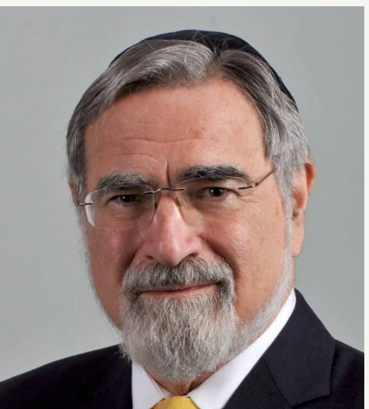

“Once in a while when you’re Chief Rabbi,” said Rabbi Jonathan Sacks, zal, “you have to deal with angry people.” He told over how he once got a very angry letter from a young man who came to his office to register for marriage only to be rejected because his soon-to-be wife was a non-orthodox convert. He wrote to the Rav saying that he’s always talking about inclusion yet here he is shutting them out.
Rabbi Sacks called him up, calmed him down, and explained that if the wife ever decides to go through an orthodox conversion, he will personally oversee it. A while later, they decided to do so.
“That’s when explosion number two occurred.” said the Rav. The young man was raging, “Your beis din expects me to keep Shabbos! I don’t need to keep Shabbos! I’m Jewish already! She needs to keep Shabbos!”
Again, the Rav calmed him down and convinced him to start keeping Shabbos. The conversion went through, and Rabbi Sacks officiated at their wedding.
Shortly after he got another call from the same man, “Chief Rabbi I have got to come around and see you.”
The Rav was thinking, “Oh no. What is it this time?”
The man came around with his wife and said, “Chief Rabbi, I just wanted to thank you for bringing Shabbos into my life. Until now I have been a workaholic. I worked seven days a week. Because of you I now have time for my wife and my family… we’re making friends… because of Shabbos, for the first time I feel part of a community… and you know what? All the work that used to take seven days only takes six now.”
Reprinted from the Parshas Yisro 5785 email of Torah Sweets.

